We have created our extruder to be as user-friendly as possible. It features rubber feet on the bottom so a customer can easily place it on any sufficiently large flat surface. While space will need to be cleared for the extruder, it is a reasonable size, measuring 770 mm long, 450 mm wide, and about 200 mm tall. We have carefully considered the safety of the customer. Cooling fans keep the machine at a safe temperature, and ventilation holes are covered by mesh panels so a user cannot access the inner mechanical components without removing the housing. An emergency stop button is present in case the extruder needs to be stopped immediately for any reason.

The extruder is completely functional and ready to be used. It is accessible because it can be powered by any standard wall outlet. The biggest limitation of the device is that to run PET flakes or pellets through it as intended, one must create PET regrind, which is extremely time consuming to do by hand. However, the intended customer, the Vanderbilt Digital Fabrication Lab, is equipped with a reclaimer to make regrind and a pelletizer to make PET pellets.

Literature from the National Defense Industrial Association (NDIA) outlines a method of calculating the Technology Readiness Level (TRL) of a product. This spreadsheet calculator builds off of NASA’s original TRL criteria, which quantify readiness on a scale from 1 to 9 with 9 being the most ready. Table 1 below shows NASA’s TRL criteria for a product. Based on this criteria, our extruder aligns most closely with TRL 9. Our extruder has been completely assembled and proven successful through creation of usable filament for Vanderbilt’s 3D printing lab.

**Table 1.** Technology Readiness Level criteria from NASA.

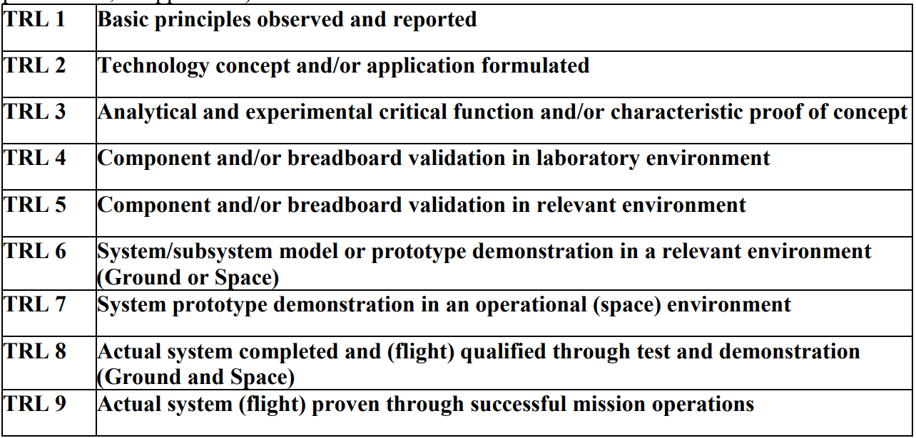

For a more thorough investigation of the TRL of our extruder, we used the spreadsheet TRL calculator from the NDIA. The NDIA TRL calculator allows the user to determine a percent readiness within each level. Figure 1 below shows the subcriteria the NDIA uses for TRL 9 with the boxes we checked according to the readiness of our extruder. The wording of some of the points necessitated inferences on our part, since our extruder is not a weapon or flight system. Using this calculator, we determined that our extruder is at 100% completion for nearly all TRL 9 requirements. We have begun a training plan by recruiting underclassmen who seem interested in continuing the running of our extruder and providing basic information on the workflow of processes such as regrind creation. However, we have not created any documentation on how to run the extruder yet. We have no program protection plan implemented or started, but we do not anticipate needing a security system to protect our extruder from foul play.

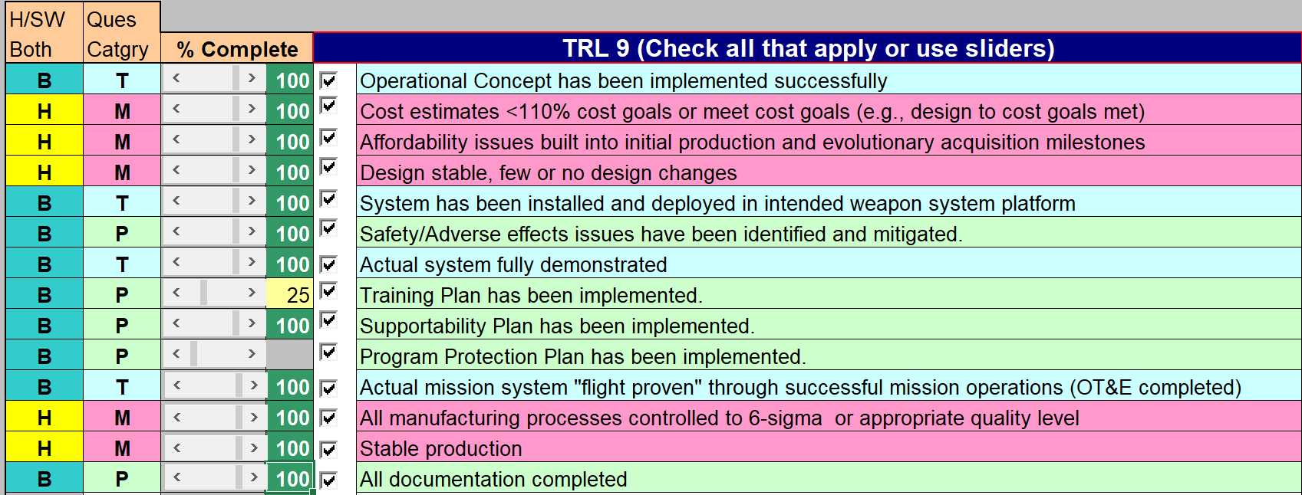

**Figure 1.** NDIA criteria for TRL 9 with our levels of completion.